Empirical optimization to improve performances of a cross-flow columnar dryer for paddy drying

⁽¹⁾Duong Thi Hong; ⁽²⁾Nguyen Van Hung, ⁽²⁾Martin Gummert
(1) Ly Tu Trong College of Technology; (2) International Rice Research Institute
Abstract
Good practices of mechanical drying can reduce losses of grain quality. Recently, with demands of higher capacity for paddy drying in the Mekong River Delta of Vietnam, columnar dryers have been introduced rapidly in this area. To improve the technology, this study was conducted to investigate and optimize a paddy drying process using a recirculating cross-flow columnar dryer. A drying batch included the passes of paddy flowing through the drying chambers and then recirculated by a bucket elevator. Drying air temperature (DAT) and pass-drying retention time of paddy flowing through the columnar drying chamber (PDR) were the researched variables to obtain optimum specific energy consumption (SEC) and maxiumum head rice recovery (HRR). A multiple-objective model reflecting for economics constituting of both SEC and HRR was built and resulted in the optimized drying process with DAT and PDR at 37.7⁰C and 26.6 minutes respectively. SEC and HRR obtained at this optimized drying set was 185.5 Wh kg⁻¹ and 60.9%, respectively. Results of this study should be significant for developments of mechanized drying, contributing to reduce rice postharvest losses and minimized drying cost.

Highlights
- Optimized parameters for drying Jasmine paddy from 28% to 14% moisture content in a recirculating cross-flow columnar dryer were established.
- Multiple-objective model reflecting to economics was built and resulted in the optimums of energy consumption and head rice recovery at 185.5 Wh kg⁻¹ and 60.9%, corresponding to drying air temperature of 37.7°C and pass retention time of 26.6 minutes.

Keywords: paddy drying, columnar dryer, air flow rate, drying temperature, drying retention time

Nomenclatures and Units:
SEC: Specific energy consumption (Wh kg⁻¹)
DAT: Drying air temperature (⁰C)
PDR: Pass - drying retention time (minutes)
HRR: Head rice recovery (%)
W: Watt
h: Hour
MCwb: Moisture content - wet basic.
MD: Mekong River Delta
SEA: Southeast Asian countries
1. Introduction
Drying plays a critical role in reducing post harvest losses of rice production. Paddy after harvesting should be dried as soon as possible – ideally within 24 hours by proper drying methods to reduce its moisture content down to about 14% that is safe for storage to prevent respiration, germination, and mould damage (Xiao and Gao, 2008; and RKB, 2016). In the 1990s simple flat bed dryers, in which a blower blows pre-heated air through stationary grain bulk until the grains are dried to the desired final moisture content, were introduced and widely adopted in the Mekong River Delta (MD) of Vietnam to replace the traditional practice of spreading the grains in the open for sun drying (Phan et al., 1995). These dryers eliminated the weather risk and somewhat increased the grain quality but still led to overdrying at the air inlet and under-drying at the air outlet of the grain bulk.
Currently in rice production regions of Southeast Asian countries (SEA), rice crops are required to be established at the same time to control the related diseases such as brown planthopper. This practice results in the need to harvest all fields in an area within a very short time window. Fortunately, the rapid introduction of combine harvesters mostly solved this demand, by 2013 about 95% of paddy in the Mekong River Delta of Vietnam (MD) was already harvested by combine harvester (Nguyen et al., 2013). However, the large amount of paddy harvested at the same time also required higher capacity for drying to reduce losses which the flat-bed dryers could not meet anymore. This situation lead to need for developing columnar dryers for not only increasing the drying capacity but also the quality of product (Nguyen et al., 2016 and Likitrattanaporn, 1993).
The principle of paddy drying using batch-columnar dryers was introduced in many studies such as drying technology in Bala (1997) and Olaniyan and Alabi (2014). A columnar dryer usually re-circulates the crop so that it undergoes cycles of drying and tempering. This also leads to more even drying because the grains are continuously mixed and more gentle drying because during the tempering process moisture moves from the inside of the grain to the outside for easier removal in the next drying cycle. Performance of a dryer is often evaluated using the quality of dried products, specific energy consumption, and drying cost. These output factors for a batch-columnar dryer depend on paddy quality and moisture content, drying air properties such as temperature and air flow rate, tempering time, pass-drying retention time of paddy flowing through the columnar drying chamber, etc. There are several recent studies on drying processes of columnar dryers such as on investigation of moisture content fluctuation in wheat in a mix-flow columnar dryer (Kocsis et al., 2011) and optimization of drying-tempering period in a columnar dryer (Morteza et al., 2012 and Kariyawasam et al, 2014). However, there are still limited publications on systematically optimizing performance of a columnar dryer to maintain the paddy grain quality with low energy consumption and particularly for the paddy in Vietnam.
Working on improving columnar dryers for paddy, we have published a paper on modeling of the paddy drying process using a cross-flow columnar dryer (Nguyen et al., 2016). In this research, grain moisture content and temperature were analysed with the objective to achieve an uniform temperature among the different layers of grain in the drying chamber in order to minimize grain damage. Following this initial research, this paper describes experiments on optimization the paddy drying performance of this cross-flow dryer for the two variables: (i) drying air temperature (DAT) and (ii) drying retention time for one pass of paddy moving through the drying chamber (PDR) of the cross-flow columnar dryer during its operation. Single- and multiple-objective optimizations were conducted to achieve the minimum specific energy consumption (SEC) and maximum head rice recovery (HRR). Results of this study should contribute significantly to develop, optimize and use of the similar columnar dryers.

2. Methodology
2.1. Experimental dryer
Figure 1 shows a schematic diagram of the laboratory recirculating columnar dryer used in the experiment. Paddy conveyed by a bucket elevator is loaded into the tempering chamber. It then passes through this tempering chamber and then through the drying chamber. The paddy therefore is exposed to repeated tempering and drying stages, typically lasting for from 20 to 30 minutes per cycle. During the drying stage, the paddy is in contact with the heated air, which is forced through across the grain bulk by the fan. While the paddy is moving downwards it is dried by this air in this drying stage and then unloaded into the bucket elevator for the next pass until it reaches the required moisture content.
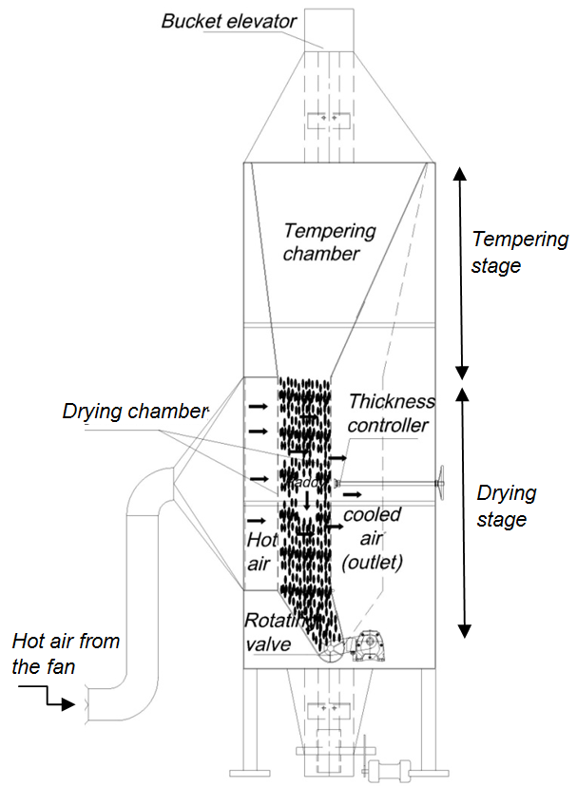
Figure1: Schematic design of experimental columnar dryer
2.2. Experimental design
Figure 2 shows the diagram of researched variables. The drying process was optimized to obtain the maximum of HRR while requiring minimum of SEC based on the researched variables of DAT and PDR. Moisture content (MC) of Jasmine paddy and the drying airflow rate were kept constant at 28% and 1 m³ s⁻ Mg⁻¹, respectively. SEC (Wh kg⁻¹) was calculated by energy consumption for each kg of paddy dried to 14%. HRR is an output representing grain quality within this research.
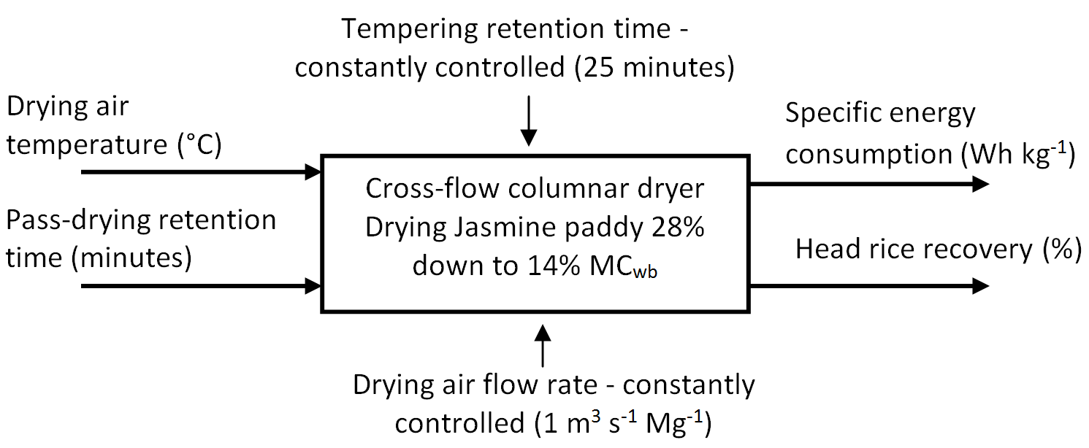
Figure 2: Input and output variables of research
Ranges of the treatments are shown in Table 1. The central level (0) was selected at 45⁰C and 25 minutes for DAT and PDR, respectively, as these drying parameters are currently used in real practices of commercial columnar dryers in MD of Vietnam (Nguyen et al., 2016). For verifying and optimizing the drying process, these input factors were expanded in both sides (-1 and +1) with adjusted values of +/-10⁰C for DAT and +/- 5 minutes for PDR.
Table 1: Ranges of the treatments
Levels | DAT  X₁ (°C) | PDR  X₂ (minutes)
+1 | 55 | 30
0 | 45 | 25
-1 | 35 | 20
2.3. Measurements and calculation
Grain MC was measured using drying oven method (ASAE, 1982). All MC mentioned in this paper are for wet basis. DAT was measured at three points along the height of the drying chamber and controlled through a resistance heater. Grain flow rate was constant across treatments, so the PDR was controlled by adjusting the height of the drying chamber until it fitted the indentified times (i.e. 20, 25, and 30 minutes). SEC and HRR were calculated based on the Equations (Eq.) 1 and 2, respectively.
SEC $=\frac{Energy consumption }{Dying capacity }$ [Wh kg⁻¹] (Eq1)
HRR $=\frac{Weight of whole grains}{Weight of paddy samples}$x100 [%] (Eq2)

2.4. Statistics and software used in analysis
STAGRAPHIC software (StatPoint Technologies Inc., 2009) was used for experimental design and data analysis including two-factor ANOVA, correlation among the factors, and regression equations. Completely randomized design (CRD) was applied based on the method of central composite design (Montgomery and Runger, 2002; Lazic, 2004). The experiment included 12 runs with 6 replications for the central level (0) and 3 replications for the bordering levels (-1) and (+1) as described in Table1 above.
The analysis was conducted sequentially as single and then multiple correlations among input and output factors. Regression equations were then built based on these input-output correlations and then used for finding optimized operational parameters. MATLAB software (MathWorks, 2016) was used for optimization based on the built regression model.
Optimizations for SEC and HRR were also analysed sequentially as single and then multiple objectives Rao (1985). Single-objective functions of SEC and HRR were built based on correlations with the two variables of DAT and PDR. Multiple-objective optimization was considered as multiple criteria decision for economic benefit including both of SEC and HRR. This function or model was established based on the Weighted-Sum Approach shown in Eq. 3.
Y = (1-λ)F₁ + λF₂ (Eq3)
where Y is a sum-objective reflecting to economic benefit including SEC and HRR that are reflected by the single-objective functions of F₁ and F₂, respectively. λ is the ratio reflecting to the weight-level or importance between SEC and HRR. This coefficient was identified by the effects of SEC and HRR on price and profit of product.
For the optimization, the SEC was targeted to minimum whereas HRR was targeted to maximum. Thus, to have the same directions for solving the optimized problems, the economic (Eco = Y) function was targeted to minimum and established corresponding to F₁ = SEC and F₂ = - HRR (Eq.4).
Y = (1-λ)SEC - λHRR (Eq4)

3. Results and discussions
3.1. Single correlations among input and output factors
3.1.1. Effects of DAT and PDR on MC reduction
Figure 3.a shows the single correlation of DAT on MC reduction with the PDR controlled at 25 minutes. A reduction of paddy MC from 28 down to 14% required from 3.5 to 10.5 h depending on DAT. Obviously, the higher DAT applied to the shorter drying time was spent to attain the required MC (i.e. 14% in this study). Similarly, Figure 3.b shows effect of PDR on MC reduction with the DAT controlled at 45⁰C. A reduction of paddy MC from 28 down to 14% required from 5 to 6 h when reducing PDR from 40 to 20 minutes. As the results, effect of PDR is lower than that of DAT to MC reduction.
Figure 3a: Effect of DAT on MC reduction | 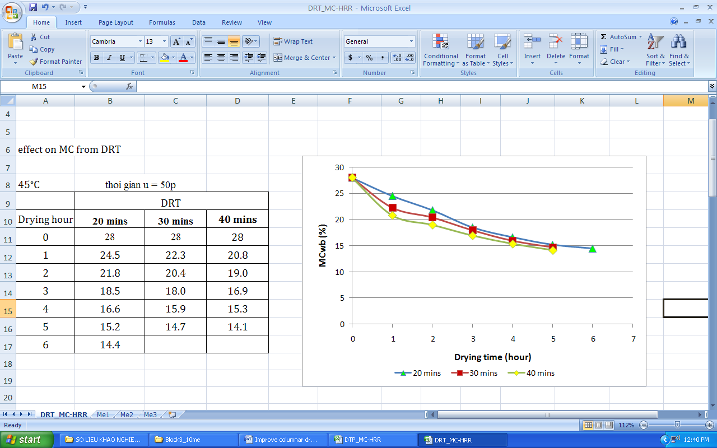  Figure 3b: Effect of PDR on MC reduction
3.1.2. Effects of DAT on HRR
Table 2 shows the effect of DAT on HRR with the PDR controlled at 25 minutes. There were significant difference (P-value <0.05 in ANOVA) among the average values of HRR corresponding to different DAT. These measurements resulted in lower HRR obtained when drying with higher temperature. Drying with DAT ranging from 35⁰C to 45⁰C generated HRR from 60 to 63% whereas drying with DAT higher than 55⁰C just obtained the HRR lower than 24%.
Table 2: HRR (%) achieved by different DAT at the PDR of 25 minutes
DAT | 35ºC | 45ºC | 55ºC | 65ºC
Replication 1 | 62.0 | 56.6 | 21.8 | 10.8
Replication 2 | 62.8 | 58.2 | 19.0 | 12.0
Replication 3 | 63.1 | 60.6 | 23.8 | 11.1
Replication 4 | 62.2 | 61.5 | 21.5 | 12.3
Replication 5 | 62.5 | 61.0 | 20.5 | 17.3
Average | 62.5 | 59.6 | 21.3 | 12.7
STDEV | 0.41 | 1.86 | 1.57 | 2.38
For PDR, we did not do the experiment with single effect of this factor on HRR. However, the multiple correlations of PDR and DAT on HRR were investigated and described in the next section.
3.2. Multiple correlations among input and output factors
Table 3 shows SEC and HRR results from the experiments with different DAT and PDR. SEC ranged from 188 to 224 Wh kg⁻¹ and HRR ranged from 21.7 to 65.5% for the different sets of DAT and PDR. Technically, drying with lower PDR may cause lower efficiency and higher SEC. On the other hand, drying with lower DAT resulted in higher HRR but it may cause longer drying time and lower efficiency. Table 4 shows the results of multiple correlations of DAT and PDR on SEC, which were analysed statistically using two-factor ANOVA.
Table 3: Results of SEC and HRR at different sets of DAT and PDR
Runs | DAT  (°C) | PDR  (minutes) | SEC  (Wh kg⁻¹) | HRR  (%)
1 | 45 | 25 | 189.2 | 55.2
2 | 45 | 25 | 189.6 | 55.3
3 | 45 | 25 | 190.1 | 54.9
4 | 35 | 20 | 209.7 | 65.5
5 | 35 | 25 | 195.4 | 65.1
6 | 55 | 30 | 224.1 | 18.7
7 | 55 | 20 | 228.4 | 22.3
8 | 45 | 25 | 191.6 | 55.0
9 | 45 | 20 | 206.3 | 57.1
10 | 45 | 30 | 200.3 | 54.2
11 | 55 | 25 | 220.1 | 21.7
12 | 35 | 30 | 192.8 | 63.2

Table 4: ANOVA for the effect of DAT and PDR on SEC
Effect | Sum of Squares | DF | Mean Sq. | F-Ratio | P-value
A:DAT | 930 | 1 | 930 | 843 | .0001
B:PDR | 123.3 | 1 | 123.3 | 111.8 | .0018
AB | 39.69 | 1 | 39.69 | 36.00 | .0093
AA | 525.5 | 1 | 525.5 | 476.6 | .0002
BB | 245.1 | 1 | 245.1 | 222.3 | .0007
Lack-of-fit | 41.40 | 3 | 13.80 | 12.52 | .0334
Pure error | 3.31 | 3 | 1.10
R-squared = 0.98
As the results in Table 4 show, all the correlative coefficients have sufficiently significant (P-value<0.05). This ANOVA resulted in a regression equation representing for the correlations of DAT and PDR on SEC shown in Eq.5.
SEC = 752.8 – 12.96DAT – 22.92PDR + 0.063DAT*PDR + 0.14DAT^2 + 0.38PDR^2 (Eq5)
The plus (+) signs in front of the variables of DAT*PDR, DAT^2, and PDR^2 in Eq.5 illustrated the positive effects of these variable sets on SEC. On the other hand, DAT and PDR in Eq.5 has its negative coefficient (-12.9 and -22.9) illustrating the negatively effects of these single factors on SEC. Figure 4 shows the multiple correlations between variables (DAT, PDR) and SEC. Drying with DAT from 35 to 45⁰C and PDR from 25 to 29 minutes required the lowest range of energy consumption from 180 to 190 Wh kg⁻¹.
Figure 4: Effects of DAT and PDR on SEC (Wh kg⁻¹)
Similarly, Table 5 shows the two-factor ANOVA for the correlations of DAT and PDR on HRR. Except for the insignificant correlation of PDR^2 on HRR (P-value>0.05), other correlative coefficients were sufficiently significant (P-value<0.05). This ANOVA resulted in a regression equation representing for the correlations of DAT and PDR on HRR as shown in Eq.6.
Table 5: ANOVA for the effect of DAT and PDR on HRR
Effect | Sum of Squares | DF | Mean Sq. | F-Ratio | P-value
A:DAT | 2864 | 1 | 2864 | 85936 | .0000
B:PDR | 12.91 | 1 | 12.91 | 387.20 | .0003
AB | .42 | 1 | .42 | 12.68 | .0378
AA | 414.2 | 1 | 414.2 | 12425 | .0000
BB | .12 | 1 | .12 | 3.61 | .1535
Lack-of-fit | 1.62 | 3 | .54 | 16.19 | .0234
Pure error | .10 | 3 | .033
R-squared = 0.98
HRR = - 100.2 + 9.36DAT – 0.0008 PDR – 0.007DAT*PDR – 0.13DAT^2 (Eq.6)
The minus (-) signs in front of all variables of PDR, DAT*PDR, and DAT^2 in Eq.6 illustrated that there was a negative correlations between the variables (DAT, PDR) and HRR. It means that HRR was obtained lower when DAT and PDR increased; and vise versa during the drying process.
Figure 5 illustrates the concentration regions of HRR affected by DAT and PDR. DAT affected strongly to HRR whereas PDR did not. HRR was higher than 55% when DAT was lower than 40⁰C. However, that HRR still can be obtained with the DAT reduced linearly from 40⁰C to 35⁰C while PDR increased from 20 minutes to 30 minutes.
Figure 5: Effects of DAT and PDR on HRR (%)

3.3. Optimization
The equations 5 and 6 built above were used to find the optimized parameters of the corresponding drying process.
Single-objective optimization for SEC obtained the optimized drying process with DAT and PDR at 40.5°C and 26.9 minutes, respectively to have the lowest energy consumption required at 181.3 Wh per kg of dried paddy (from 28 down to 14%). The HRR obtained at this optimized point was 58%.
Single-objective optimization for HRR resulted in the highest HRR of 60% for drying Jasmine paddy from 28% down to 14%. This drying process required DAT lower than 35.5⁰C at any level of PDR; or DAT lower than 40°C with PDR lower than 20 minutes.
Multiple-objective optimization was analysed based on Eq.4 above. The economic benefit (Eco) was obtained as in Eq. 7 constituting of both of SEC and (-HRR) functions built based on DAT and PDR.
Eco = 753.8 -652.6λ + (3.6λ -12.96)DAT + (22.92λ -22.92)PDR – (0.06λ – 0.063)DAT*PDR – (0.01λ-0.14)DAT^2 – (0.38λ – 0.38)PDR^2 (Eq7)
This weighted-sum model Eco can result in differently optimized results with different λ which depends on many factors such as prices of rice and energy, Market price based on head rice, etc. There is very limited publication on the effects of HRR on rice price. Within this discussion, we calculated the weighted-ratio and λ coefficient between HRR and SEC based on the information and assumptions as shown in Table 6.
Table 6: Effecting-value of SEC and HRR on economics
Parameters/Information | Source | Convert to effecting-value (USD t⁻¹) | Notes
Rice price (Vietnam) | Rice Authority (2016 ) | 428 | Used for calculating effects of HRR on price
Effect of HRR on price
Price of rice increase 0.09% for 1% increased HRR | Unnevehr et al. (1992 ) | 38.52 | Increased USD by ton paddy with HRR increased 1%
Market price reductions of $0.0075 to $0.0119 per kg | Michael et al. (2013 ) | 9.7 | Assumed an average increase of price per ton by 5% of HRR increased
Price of exported rice of Vietnam is lower than that of Thailand 10-30% caused by the factors involved HRR | Nguyen V.S. (2013) | 21.4 | Assumed 5% of price increased by 5% of HRR increased
Effect of SEC on price
Average consumption: 200 Wh kg⁻¹ | Resulted from research | 18.35 | Price of electric power in Vietnam: 0.09175 USD kWh⁻¹ ⁽MOIT, 2013 )
The average effecting-values in Table 6 established the weighted-ratio of 1.27 between of HRR and SEC. This ratio resulted in the coefficient of λ equaling to 0.559. With this λ, the Eq.7 above is identified as shown in Eq.8.
Eco = 387.7 - 10.95DAT - 10.1PDR + 0.032DAT*PDR + 0.134DAT^2 + 0.167PDR^2 (Eq8)
Figure 6 illustrates correlation of the parameters. This model resulted in the optimized DAT and PDR of 37.7⁰C and 26.6 minutes, respectively. SEC and HRR obtained at this optimized point were 60.9% and 185.5 Wh kg⁻¹, respectively.
Figure 6: Multiple correlation of DAT and PDR on Eco
4. Conclusion
Improving drying technology, particularly with columnar dryer for paddy is important to fulfill the demands for drying capacity and quality of products and to contribute significantly to reduce rice postharvest losses and add value to rice value chain. This study investigated and optimized a paddy-drying process in a cross-flow columnar dryer with its batch-recirculating operation. Optimized drying parameters for drying Jasmine paddy from 28% to 14% moisture content were established. Optimized head rice recovery was obtained at 60% corresponding to drying temperature lower than 40⁰C and drying retention time in a pass of 20 minutes. On the other hand, drying paddy with air temperature of 40.5°C and pass-retention time of 26.9 minutes required the lowest energy consumption at 181.3 Wh kg⁻¹ of dried paddy and obtained HRR of 58% at this point. A multiple-objective model reflecting for economic benefit was built and resulted in the optimized drying process with DAT and PDR at 37.7⁰C and 26.6 minutes. Drying paddy with this optimized parameters attained SEC and HRR of 185.5 Wh kg⁻¹ and 60.9%, respectively. Results of this study are significant for development and optimization of mechanized drying in re-circulating batch columnar dryers, contributing to reduce rice postharvest losses.

Acknowledgements
The research group acknowledges the support of the ADB-IRRI Postharvest Project, namely “Bringing about a Sustainable Agronomic Revolution in Rice Production in Asia by Reducing Preventable Pre- and Postharvest Losses” – RETA 14, 2009-2014.

References
ASAE, 1982. ASAE Standard (29th Edn.), S3521. Moisture measurement}grain and seeds. St. Joseph, MI, USA.
Bala, B. K. 1997. Drying and storage of cereal grains. Oxford & IBH publishing Co. Pvt. Ltd.
Lazic, Z. R.. 2004. Design of Experiments in Chemical Engineering. WILEY-VCH Verlag GmbH & Co. KGaA, Weinheim.
Likitrattanaporn, C. 1993. Evaluation of the performance of the non-mixing columnar rice dryer. Available at: http://agris.fao.org/agris-search/search.do?recordID=TH1998001271.
Kocsis L., Keppler I., Herdovics M., Fenyvesi L., and Farkas I.,2011. Investigation of moisture content fluctuation in mixedflow dryer. Agronomy Research Biosystem Engineering Special Issue 1, 99-105, 2011. http://agronomy.emu.ee/vol09Spec1/p09s113.pdf.
MathWorks, 2012. Matlab R2012a. http://en.freedownloadmanager.org/Windows-PC/MATLAB-R2012a.html.
Michael E.S., Michael A.D., Steven D.L., Charles E.W., Timothy W. W., Garry N.M. and David C.B., 2013. Impact of Harvest Lodging on Rough Rice Milling Yield and Market Price. Agron. J. 105:1860–1867 (2013) doi:10.2134/agronj2013.0238.
MOIT, 2013. Price of electric power. http://www.moit.gov.vn/en/News/495/the-average-retail-price-of-electricity-up-to-1-835-vnd-kwh-until-2015.aspx.
Montgomery, D.C. and Runger, G.C., 2002. Applied statistic and probability for engineers, 3nd edn., john Wiley &Son, Inc, New York, 976 pages.
Morteza, G., M. Rajabi-Hamane, and S. J. Hashemi. 2012. Optimization of Drying–Tempering Periods in a Paddy Rice Dryer. Drying Technology, 30(1): 106–113.
Nguyen V.H., Duong T.H., Gummert M., 2016. Building a model for the paddy columnar dryer and analyzing a reverse-airflow approach to achieve uniform grain temperature. International Agricultural Engineering Journal. 2016, 25(1): 64-73.
Nguyen V. H., Nguyen L.H., Truong Q.T.,and Phan H.H., 2013. Drivers of Postharvest Development and Milestones of ADB-IRRI Rice Postharvest Project in Vietnam. https://baa4a644-a-d6d9d6da-s-sites.googlegroups.com/a/irri.org/posthavest-unit/vietnam/Postharvest%20status-ADB-IRRI%20-VN%20Proj.pdf?attachauth=ANoY7crV16gc6kWQKS6gjAdnbPTNpZR43yi045zQTw-da46gnYEIIdCVDNjwVQps02bGcnKNcM3hfGup1kkToulc7Y50vHE_ulwpiM9uAwul7jDMc6Q-h83dKipnXTpGgSX4JYsuyfx3wE5brzCuyqwAzzbSqvCqR6afkrRX8dAmxThqYlu5rcmzNSS55HshPFrUgumej2OcbcRy6W3QInukz2agMcoyr2VN_WFPgzKzbzy81QsiUwMDZFTN_QqIfiyECwqWOdAS&attredirects=0.
Nguyen V.S., 2013. Rice value chain of Vietnam. Sea Freight Logistics Vietnam 2013. http://www.ou.edu.vn/ktl/Documents/Tham%20luan_%20Nguyen%20Van%20Son.pdf.
Olaniyan, A. M., and A. A. Alabi, 2014. Conceptual Design of Column Dryer for Paddy Rice including Fabrication and Testing of Prototype. International Journal of Basic and Applied Science, 2(3): 11-20.
Phan H.H., Nguyen H.T., Truong V., and Nguyen Q.L., 1995. Grain Drying in Vietnam: Problems and Priorities. Grain Drying in Asia - Proceedings of an International Conference held at the FAO Regional Office for Asia and the Pacific, Bangkok, Thailand, 17-20 October 1995: 57-67. http://ageconsearch.umn.edu/bitstream/134747/2/PR071.pdf
Rao, S.S. 1985. Optimization – Theory and Apllication. New Age International (P) Limited, Publishers Wiley Eastern Limited.
Rice Authority. 2016. Price. http://www.riceauthority.com/prices/
RKB, 2016. Paddy drying. http://rkb.irri.org/step-by-step-production/postharvest/drying.
Schluterman, G. J., and T. J. Siebenmorgen. 2004. Air and Rice Property Profiles within a Commercial Cross−Flow Rice Dryer. American Society of Agricultural Engineers, 20(4): 487−494.
StatPoint Technologies Inc., 2009. Stagraphics centurion XVI user manual. www.STATGRAPHICS.com
Tran, V. T., N. V. Hung, N. V. Xuan, N. H. Tam, Q. V. Le, T. Q. Truong, and H. H. Phan. 2013. Design and development of the 10-ton/batch columnar paddy dryer. Proceedings of International Workshop on Agricultural Engineering and Post-harvest Technology for Asia sustainability. Science and Technics Publishing House, 2013 (12): 152–163.
Unnevehr, B. D. and Juliano B.O. 1992. Consumer demand for rice grain quality. Terminal Report of IDRC Projects National Grain Quality (Asia) and International Grain Quality Economics (Asia). http://books.irri.org/9712200302_content.pdf.
Xiao, H. W., and Z. J. Gao. 2008. Research progress in the effects of drying on feeding maize and processing quality. Transactions of the Chinese Society of Agriculural Engineering, 24(7): 290-295. (in Chinese with English abstract).

